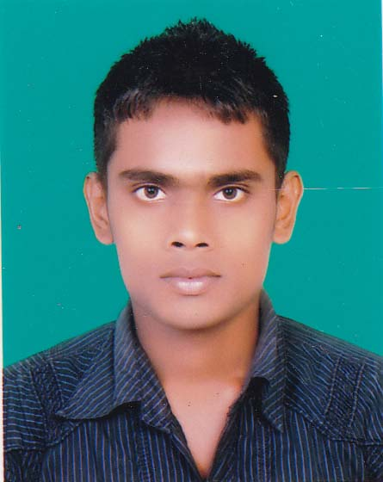
CURRICULUM VITAE
OF
MD.ABU SAYED
Contact: 01722252594

OBJECTIVE

I am searching suitable job to obtain a position that will enable me to use my strong organizational skills, educational background, and ability to work well with people in any institution or organization.

Personal Details

Father’s Name : Md. Majedur Rahman
Mother’s Name : Mst. Samina Begum
Permanent Address : Village: Tazpur (Bangal Pukur), Post: Khanpur, Thana: Sadar,
District: Dinajpur.
Nationality : Bangladeshi (by birth)
Date of Birth : 15/12/1995
Place of Birth : Tazpur
Sex : Male
Marital Status : Unmarried
Religion : Muslim (Sunni)
Height & Weight : 5`-5`` & 57 kg
Blood Group : AB^{(+ve)}

Educational Background

Examination : B.B.A (Hons.)
Institution : Dinajpur Govt.College, Dinajpur
Group : Accounting.
Board : Dhaka Board.
Result (GPA) : Appeared
Sessions : 2013-2014

Examination : H.S.C
Institution : Dinajpur Govt.Commercial Institute, Dinajpur
Group : Accounting.
Board : Dhaka Board.
Result (GPA) : 5.00 [Out of 5]
Passing Year : 2013
Examination : S.S.C
Institution : Mohanpur High School, Dinajpur
Group : Humanities
Board : Dinajpur Board.
Result (GPA) : 4.13
Passing Year : 2011

IT Knowledge

* Have a good command on Microsoft Word, Excel, PowerPoint, Website & Internet Browsing (Excellent in typing both English & Bengali)

Language Proficiency

* Have excellent command on listening, speaking, reading & writing both Bengali & English languages.

Other Skills

* Excellent communication skills
* Problem solving and decision making skills
* Team player Motivated, driven and dedicated
* Good controlling & planning
* Good co-operative & co-ordination skills

DECLARATION

I, the undersigned certify that to the best of my knowledge and belief, these data are correctly described my qualifications and experiences.


Signature

Date:

